E322 Principles of Epidemiology Mortality Rate Adjustment
Heart disease is the leading cause of death for both men and women, and more than half of the deaths due to heart disease in 2015 were in men (1). In fact, each year, 1 in 4 deaths (630,000 Americans) is due to heart disease. Further, heart disease is the leading cause of death for most racial/ethnic groups in the United States including African Americans, Hispanics, and Whites, though mortality rates among African Americans remain higher than other races/ethnicities. For Asian Americans or Pacific Islanders and American Indians or Alaska Natives, heart disease is second only to cancer (2). Each year, the cost of medications, health care services, and lost productivity due to heart disease costs the United States an estimated $200,000,000,000 (1). Considering the significant morbidity, mortality, and economic burden, it is of great public health interest to control and prevent heart disease.
One population-wide intervention which has shown to decrease risk for myocardial infarction in several urban communities is smoking bans (3). Consider a scenario in which Marion County, IN is instituting a county-wide smoking ban. As a component to the evaluation of this program, you’re interested in determining if any changes in heart disease mortality occur after five years of the smoking ban, and how this compares with other counties who have instituted smoking bans. In order to set a baseline for the mortality in Marion County, IN – prior to the ban – you are to query CDC WONDER and determine the current mortality rates for heart disease. You will also compare these baseline rates to another urban county which has instituted a smoking ban and is of similar population size – San Francisco County, CA. Below are the parameters of your query (unless otherwise stated use the default settings):
Counties – Marion County, Indiana and San Francisco County, California
Age groups – 35 years and older
Race / ethnicity – All Hispanic origins. Asian or Pacific Islanders, Black or African Americans, and Whites
Years – 2010-2015
Causes of death – ICD010 codes I20 – I25 (Ischaemic heart diseases)
- What are the crude mortality rates for ischaemic heart diseases in Marion County, Indiana and San Francisco County, California? Do you believe these rates are comparable? Why or why not?

San Francisco
4001/ 2782344 × 100000 = 208. 28 Which equals to 2018 deaths per 100000 population
Marion County
5581/ 2679584 × 100000= 143.8 .This is 143.8 deaths per 100000 population.
In the United States, death leading cause is heart disease. However, from my own understanding the comparison of the two results is not comparable due to the geographical different lifestyles.

- What are the gender-specific mortality rates for ischaemic heart diseases in Marion County, Indiana and San Francisco County, California (complete the table below)?

 | San Francisco CO |  |  | Marion CO
Gender | Pop | Deaths | Rate/100000 | Pop | Deaths | Rate/100000
Female | 1363733 | 1859 | 136.3 | 1431174 | 2441 | 170.6
Male | 1418611 | 2142 | 151 | 1248410 | 3140 | 251.5
Total | 2782344 | 4001 | 287.3 | 2679584 | 5581 | 422.1

- Calculate the gender-adjusted mortality rates for ischaemic heart diseases in Marion County, Indiana and San Francisco County, California (and complete the table below).
 |  | San Francisco CO | Marion CO
Gender | Standard population | Expected Deaths | Expected Deaths
Female | 2794907 | 3809.6 | 4768.1
Male | 2667021 | 4027.2 | 6607.6
Total | 5461928 | 7836.8 | 11475.7

Gender-adjusted IHD rate for Marion County, Indiana =
11475.7/ 5461928 × 100000= 210. 1 per 100,000 population

Gender-adjusted IHD rate for San Francisco County, California =
7836.8/5461928 × 100000= 143. 48

- What are the race-specific mortality rates for ischaemic heart diseases in Marion County, Indiana and San Francisco County, California (complete the table below)?
 | San Francisco CO |  |  | Marion CO
Race | Pop | Deaths | Rate  /100000 | Pop | Deaths | Rate  /100000
Asian or Pacific Islander | 1070573 | 1301 | 121.5 | 57591 | 32 | 55.6
Black or African American | 185377 | 420 | 226.6 | 687261 | 1292 | 188
White | 1526394 | 2280 | 149.4 | 1934732 | 4257 | 220
Total | 2782344 | 4001 | 143.8 | 2679584 | 5581 | 208.3

- Calculate the race-adjusted mortality rates for ischaemic heart diseases in Marion County, Indiana and San Francisco County, California (and complete the table below).
 |  | San Francisco CO | Marion CO
Race | Standard population | Expected Deaths | Expected Deaths
Asian or Pacific Islander | 1128164 | 1370.7 | 627.2
Black or African American | 872638 | 1977.4 | 1640.6
White | 3461126 | 5170.9 | 7614.5
Total | 5461928 | 8519 | 9882.3

Race-adjusted IHD rate for Marion County, Indiana =

9882.3/54461928 × 100000 = 180.93 per 100000

Race-adjusted IHD rate for San Francisco County, California =

8519/5461928 ×100000= 156 per 100000

- What are the age-specific mortality rates for ischaemic heart diseases in Marion County, Indiana and San Francisco County, California (complete the table below)?

 | San Francisco CO |  |  | Marion CO
Age | Pop | Deaths | Rate  /100000 | Pop | Deaths | Rate  /100000
35-44 years | 802611 | 35 | 4.36 | 710635 | 101 | 14.21
45-54 years | 675309 | 97 | 14.36 | 735721 | 480 | 65.24
55-64 years | 602601 | 330 | 54.76 | 625479 | 923 | 147.57
65-74 years | 361323 | 482 | 133.4 | 334400 | 1021 | 305.32
75-84 years | 227186 | 989 | 435.33 | 186170 | 1367 | 734.28
85+ years | 113314 | 2068 | 1825.02 | 87629 | 1689 | 1927.44
Total | 2782344 | 4001 | 143.8 | 2679584 | 5581 | 208.28

- Calculate the age-adjusted mortality rates for ischaemic heart diseases in Marion County, Indiana and San Francisco County, California (and complete the table below).
 |  | San Francisco CO | Marion CO
Age | Standard population | Expected Deaths | Expected Deaths
35-44 years | 1513246 | 66.6 | 214.9
45-54 years | 1410580 | 203.1 | 912.1
55-64 years | 1228080 | 673 | 1812.6
65-74 years | 695723 | 928.1 | 2124
75-84 years | 413356 | 1799.3 | 3053.3
85+ years | 200943 | 3667.2 | 3873
Total | 5461928 | 7337.3 | 11971.9

Age-adjusted IHD rate for Marion County, Indiana =

11971.9/ 5461928 × 100000 = 219.19 per 100000

Age-adjusted IHD rate for San Francisco County, California =

7337.3/ 5461928 × 100000 = 134.34 per 100000

- Using CDC WONDER, determine the race-specific, age-adjusted rates for ischaemic heart diseases in Marion County, Indiana and San Francisco County, California for both the 2000 Standard Million Reference Population and the 1940 Standard Million Reference Population. You may report these in a table, as done above, or as a cropped screen capture from the CDC WONDER webpage.

- 2000 Standard Million Reference Population

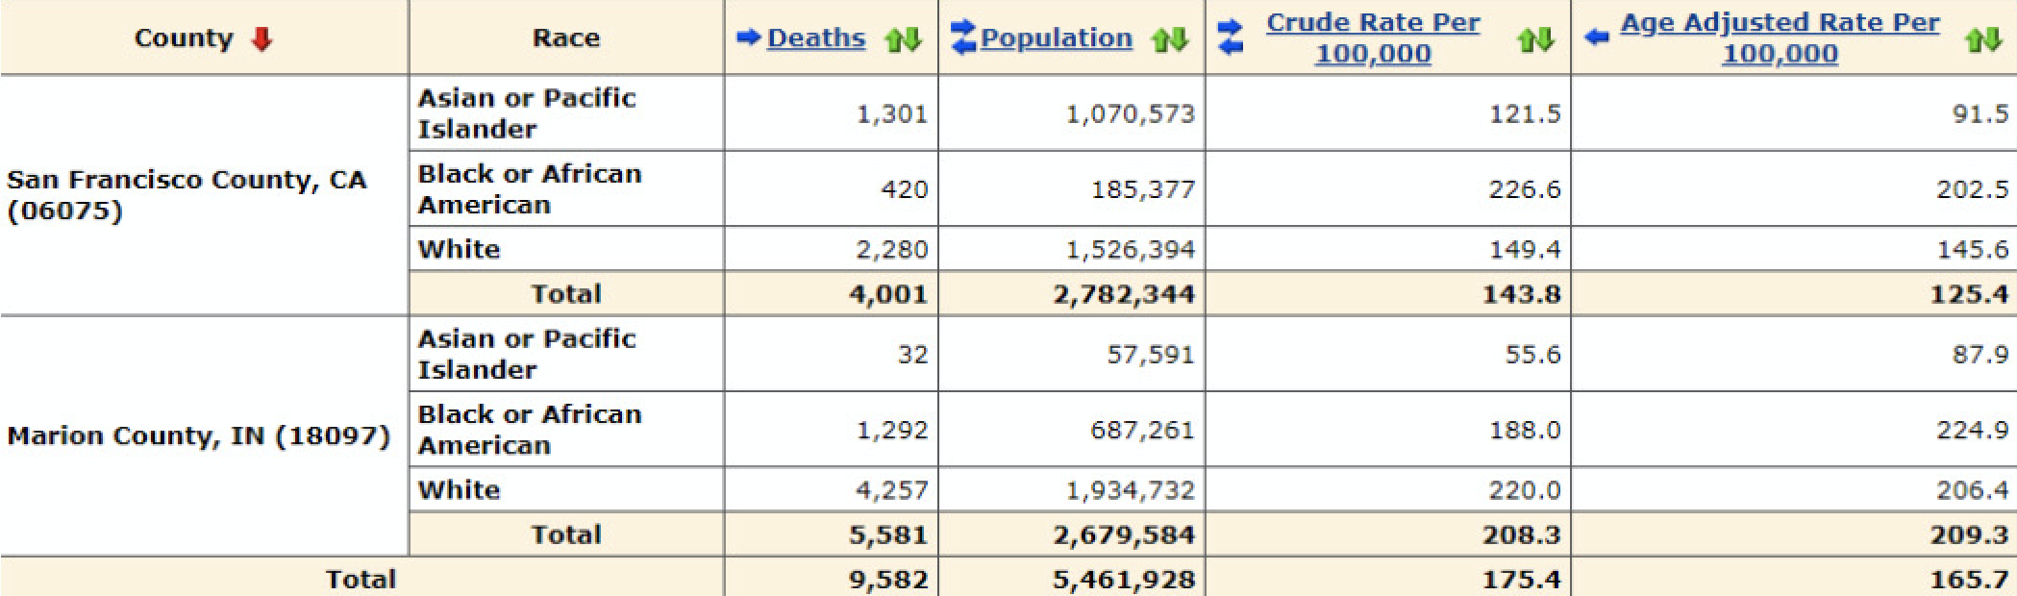

- 1940 Standard Million Reference Population

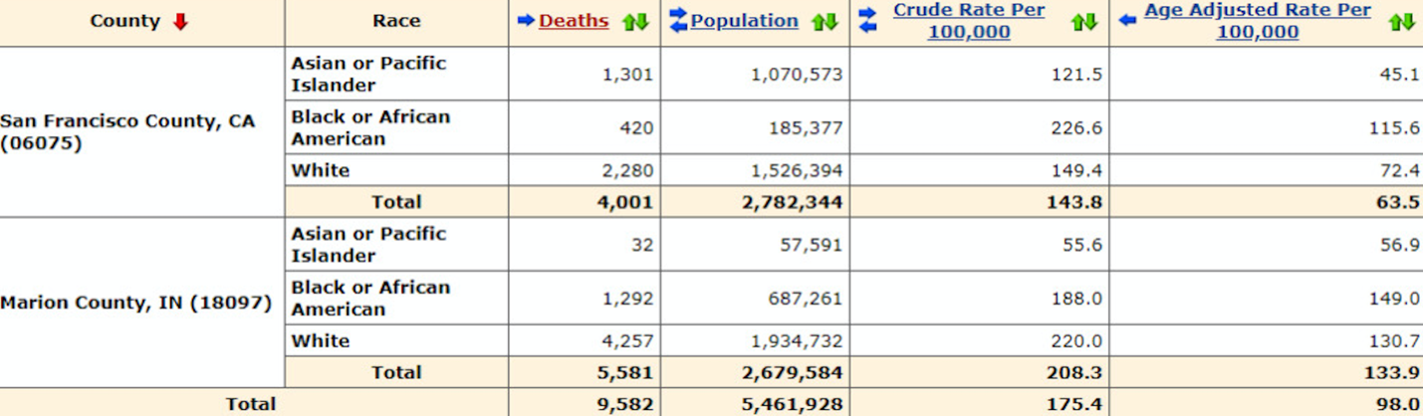

- Compare the race-specific, age-adjusted rates for ischaemic heart diseases in Marion County, Indiana and San Francisco County, California between the 2000 and 1940 Standard Million Populations.

The similarity is that the 1940 adjusted rates were lower than the 200 million population

- Examine the age distributions for the 2000 and 1940 Standard Million Populations in the tables below. Do you notice any differences that might explain what you observed in part c?

When it comes to differences, there are no huge differences between 2000 and 1940 standard million populations’ age distributions.

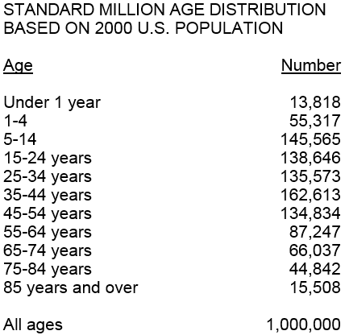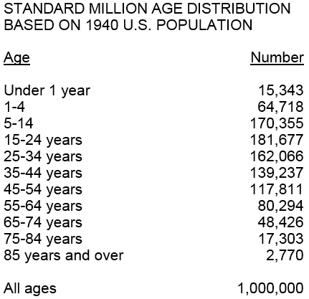

- Complete the table depicting the crude, gender-adjusted, race-adjusted, and age-adjusted mortality rates for ischaemic heart diseases in Marion County, Indiana and San Francisco County, California.
Rates | San Francisco CO | Marion CO
Crude | 143.8 | 208.3
Gender-adjusted | 143.5 | 210.1
Race-adjusted | 156 | 180.9
Age-adjusted | 134.3 | 219.2

- Discuss how the rates from your analyses (table from #9) compare with each other. Are the distributions of gender, race, and age similar between Marion County, IN and San Francisco County, CA? Finally, which rates will you choose as a baseline for your intervention evaluation?

The need to account influencing factors will lead to an elimination of the differences. In San Francisco County, the overall rates are lower in comparison to Marion County. The difference in rates is likely to be associated with the ban on smoking which is not available in Marion County. For my baseline intervention evauation, I would choose age and race adjusted rates.

References
- Centers for Disease Control and Prevention, National Center for Health Statistics. Multiple Cause of Death 1999-2015 on CDC WONDER Online Database, released December 2016. Data are from the Multiple Cause of Death Files, 1999-2015, as compiled from data provided by the 57 vital statistics jurisdictions through the Vital Statistics Cooperative Program. Accessed at http://wonder.cdc.gov/mcd-icd10.html.
- Benjamin EJ, Blaha MJ, Chiuve SE, Cushman M, Das SR, Deo R, et al. Heart Disease and Stroke Statistics—2017 Update: A Report From the American Heart Association. Circulation. 2017;135:e1–e458.
- Lin H, Want H, Wu W, Lang L, Want Q, Tian L. (2013). The effects of smoke-free legislation on acute myocardial infarction: a systematic review and meta-analysis. BMC Public Health. 13:529.

